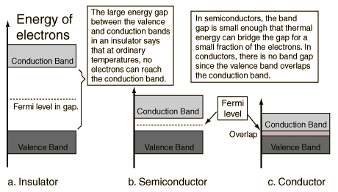

**Insulators, conductors and semiconductors**

An **energy band diagram** is often used to illustrate the conductive properties of an atomic structure. The vertical axis corresponds total energy of an atomic electron and the horizontal axis to the position in space in the atomic structure. Valence electrons have energies indicated by the **valence band** (bottom band). Free electrons that are responsible for conduction lie in the **conduction band** (top band). **Fermi energy level** represents the maximum electron energy at absolute zero temperature (0K) and lies in-between the two bands. In diagrams, the area within the bands are usually shaded to indicate allowed electron energy states. The energy bands may or may not overlap. In the latter case, there is a gap between the bands which contains forbidden electron energies. This gap it is called the **band-gap**. The width of the band-gap $ΔE$ is the difference between the lowest energy in the conduction band $E_{C}$ and the highest energy in the valence band $E_{V}$. A valence electron must collect energy no lesser than $ΔE$ to enter the conduction band.

An **insulator** is a poor conductive material that does not conduct electric current. Its energy diagram (fig??) shows that the gap between the energy bands is large. In fact, it is so large that electrons have great difficulty crossing the forbidden region and entering the conduction band.

In contrast, a **conductor** is a highly conductive material that readily allows the flow of electric current. The valence and conduction band overlap and create a union. There is no band-gap and electrons may flow freely from one band to the other.

A **semiconductor** is a material whose conductivity lies between an insulators and a conductors. The conductivity depends on its temperature and composite material. Rising temperature increases the kinetic energy of the valence electrons and determine whether they have enough energy to leap over the band-gap and into the conduction band. At low temperatures a semiconductor behaves like an insulator and with increasing temperatures the conductivity rises, eventually resembling that of a conductor. The conductive properties can also be altered by doping the material with impurities. Such semiconductors are called **doped** or **extrinsic semiconductors**.

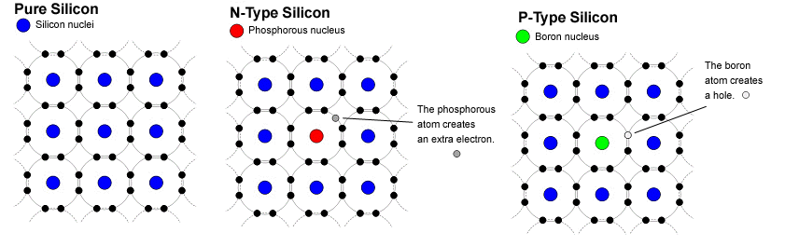

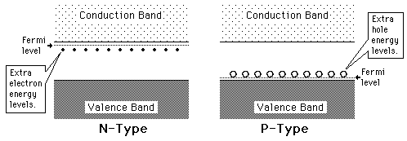

**Doped semiconductors**

When speaking about semiconductors, **doping** is the process of injecting impurities into the structure. Adding impurities to a pure semiconductor alters its electrical conductivity by introducing allowed energy states to the band-gap. These impurity states appear close to either the conduction band or valence band depending on the type of impurity atom. The number of valence electrons of an impurity atom determines the doping type. Semiconductors in which added dopant(?) has one electron more than the atom of the crystal structure are n-type while those with impurity atoms an electron short are p-type.

The most common semiconductor material is silicon (Si). Silicon belongs in group IV of the periodic table and thus has four electrons in its outer shell. In a pure silicon crystal structure, the four outer electrons each form a covalent bond with a neighboring electron of another Si-atom. At thermal equilibrium, the only accepted energy states are in the valence band. If sufficient energy, at minimum the band-gap, is transferred to the valence electrons, they will excite to the conduction band.

A neutrally charged phosphorous (P) atom has five valence electrons, one more than a Si-atom, and as an impurity in the crystal lattice, it acts as an electron donor. Four out of its five electrons form covalent bonds with valence electron of neighboring Si-atoms. The fifth donor electron is left loosely bound to the P-atom and, thus, is more easily excited to the conduction band.

In contrast, a neutrally charged boron (B) atom has three valence electrons. While phosphorous supplies electrons, a boron impurity contributes to electron vacancies, also known as holes. The holes in the Si-structure acts as electron acceptors. Valence electrons may fill a hole and, in its wake, leave a new hole. One could also say the two charge carriers (interchange?) switch positions

Figure ?? illustrates the energy band diagram of a p-type (right) and an n-type (left) semiconductor.

In p-type, **donor state** appears in close proximity of the conduction band and in n-type **acceptor states** and lie just above the valence band. The gap between an impurity state and the closest band is referred to as the **dopant-site energy gap** and it is significantly smaller than the band-gap. Acceptor levels elevate valence electrons slightly above the valence band and donnor levels supply an electron in an energy state extremely close to the conduction band. Need a sentence here. Adding impurities lessens the energy required to excite an electron and consequently increases the materials conductivity.

**PN-junction diode**

Combining extrinsic semiconductors of different type can create a diode, an electrical component which allows the easy passage of current in one direction but prohibits it in the other. The combination of a p-type and n-type semiconductor creates a pn-junction diode. *The* ***composition*** *of a pn-junction can be seen in Fig. ??*

A pn-junction is the interface between an n-type and a p-type. N-type have an excess of negative charge carriers (electrons) and p-type have an excess of positive charge carriers (holes)*.* When the two extrinsic semiconductors are joined, the process of charge diffusion is set in motion. Electrons from the n-type drift towards the p-type and combine with positive charge carriers, while holes from the p-type make their way to the n-type and combine with negative charge carriers. Naturally, an electric field (and a potential barrier) instantaneously forms and increases as charges accumulate in opposite regions near pn-junction. Once the potential barrier reaches an impassable magnitude, the diffusion of charge comes to a halt and the system is said to have reached thermal equilibrium.

The **depletion region** is the zone in a pn-junction where no mobile charge carriers are present and only ionized impurity atoms remain. In the depletion region, near the junction the p-type has a negative space charge region and the n-type a positive space charge region. The generated electric field only exists in the depletion region and points from n-type (positive region) to p-type (negative region) inside the depletion region. Thus, any charge carrier that may appear in the semiconductor material moves with respect to the electric field inside the depletion region and by diffusion outside the depletion region. In other words, the pn-junction behaves like a diode, allowing current to flow freely in one direction while prohibiting it in the other.

Rewrite this

**Reverse Bias**

An external voltage source (e.g. a battery) can change the properties of a pn-junction diode. Reverse bias voltage is created by attaching (+) pole to n-side and the (-) pole to p-side such that the electric field caused by the bias points in the direction of electric field in the depletion region. Electrons on the n-side are attracted to (+) and holes to (-). The free charge carriers are pulled even further away from the pn-junction. A reverse bias thus increases the depletion regions width.

Oppositely, a forward bias connects (+) and (-) poles to p-side and n-side, respectively, and force charge carriers closer to the pn-junction. The depletion region width decreases. Sentence about removing the bandgap completely

The pn-junction diode described above combined with reverse bias acts as a very simple semiconductor particle detector. A particle traversing the depletion region ionizes composite atoms and creates electron-hole (e-h) pairs which gives rise to a pulse signal, indicating the ionizing particles presence.

**Charge collection?/Charge integration/Signal**

A pn-diode is integrated into an electric circuit with the help of electrodes; electrical conductors used to connect non-metallic components, such as semiconductors, into circuits. By the basic physical phenomenon of electrostatic induction, an arbitrary moving point charge induces opposite charge in a conductor. An ionizing particle traversing the pn-diode generates electron-hole pairs. The presence of an electric field causes the electrons and holes to drift towards respective ends of the diode to which an electrode is attached. The moving charge carriers gradually induce increasing charge in the electrodes and are responsible for the pulse signal registered by readout electronics. The induced charge grows as charge carriers accumulate and comes to a holt once complete charge collection has been achieved. The charge collection time can be shortened (i.e. improved) by increasing the electric field strength. Which electric field? (Figure? **Pulse signal?)**

In a pn-diode **without a bias**, there is only an electric field in the depletion region. Charge carriers produced in the depletion region are swept away by the local electric field and induce a pulse signal in the electrodes. In the undepleted region where there is no electric field, charge carries are subject to charge recombination with majority carriers. Hence the induced signal owes its realization to charge generated in the depletion.

**With reverse bias** the depletion region becomes larger and its local electric field increases. A larger depletion region means more signal inducing charge carriers can be produced. Since charge carriers in the depletion region experience a stronger electric field they accelerate and are, thus, collected faster.

Remove this? In alpide we rely on electrons produced in epitaxial, which is not the depletion region…

As a particle detector the pn-diodes depletion region is considered the sensitive volume. Is it? It is the charge carriers produced in this area who are responsible for pulse generation observed by the readout electronics. The amount of charge and collection time thereof plays a role in the detector’s sensitivity. A pn-diode coupled with reverse bias enlarges the sensitive volume, giving room for greater charge production and faster signal generation. Reverse bias thus improves the spatial, energy and time resolution of the detector.

Considered as a particle detector the pn-diode becomes more effective when coupled with revers bias, the spatial and energy resolution is increased and charge collection time is reduced.

Also, an electric field is present across the whole pn-diode, not just locally in the depletion region. This isn’t true? Even though the undepleted region now has an electric field, the charge carriers produced in said region are still highly prone to charge recombination due to the high density of majority carriers. The induced signal is mainly caused by charge carriers in the depletion region. Reverse biasing

**Pulse signal generation**

<https://www.science.mcmaster.ca/radgrad/images/6R06CourseResources/4RA34RB3_Lecture_Note_7_Semiconductor_Detectors.pdf>

Thus, the direction of the electric field is such that it opposes further diffusion of electrons and holes.

**How is the pn-junction connected to a pixel sensor?**